Dr. M.FARZANA BEGUM
Plot NO-248, T.S.N.Avenue
Opp. Annai Ashramam High School
Trichy-07
MO.NO- 9790024804
E.MAIL ID: farzanashowkath@gmail.com

ACADEMIC RECORD
Philosophy of Doctorate (Ph.D)
- Period : 2018-2021
- College : A.V.V.M.Sri Pushpam College,Poondi
- University : Bharathidasan university
- Project : Talent Management and its Impact of Organisational Performance- A Study with focus on Public Sector Banks in Tiruchirappalli
Master Philosophy (M.Phil)
- Period : 2011-2012
- College : Jamal Mohamed college
- University : Bharathidasan university
- Project : A study on working capital analysis in fast moving consumer goods in India
POST GRADUATION
Master of Business Administration (M.B.A)
- Period : 2009-2011
- College : Bharathidasan university
- Aggregate : 64.99%
- Project : Financial analysis for public sectors and public sector steel industries
UNDER GRADUATION
Bachelor of Business Administration (B.B.A)
- Period : 2007-2009
- College : Bharathidasan university
- Discipline : Business Administration
- Aggregate : II nd class.
HSC - St.Philominas girls Secondary School, Trichy – 620 016
March 1999 66%
SSLC - St.Philominas girls Secondary School, Trichy – 620 016
March 1997 68.2%

TECHNICAL QUALIFICATION
1 Tally Accounting Package - 1st Class
2 DTP MS- Office 1st Class with Distinction

EXPERIENCE: PG- 1YEAR
UG-10 Years and 7 months
AREA OF SPEALISATION
- Finance
- HR
S.NO | DESIGNATION | YEARS OF SERVICE | PERIOD OF SERVICE
1. | Assistant Professor  Department of Business Administration,  Jamal Mohamed College,  TVS Tolgate,  Trichy 620 020. | 10 Years and 7 Months | 2023 to till date
2. | Assistant Professor  PG and research Department Commerce,  Jamal Mohamed College,  TVS Tolgate,  Trichy 620 020 | 1YEAR | JUNE-2013
3. | GUEST LECTURER  PG and research Department of Commerce,  Jamal Mohamed College,  TVS Tolgate,  Trichy 620 020 | I YEAR | JUNE-2012

SEMINAR PAPER PRESENTATION AT INTERNATIONAL LEVEL ( 9)
1. Jamal Mohamed College, Department of BBA & PG Department of Commerce (SF), TVS Tolgate, Trichy – 620 020. GLOBAL COMPETITIVENESS – A CHALLENGE FOR SUSTENANCE AND EXCELLENCE. GLOBAL COMPETITIVENESS- CORPORATE GOVERNANCE ISSN: 2250-1940 16th and 17th Aug – 2013
2. Jamal Mohamed College, Department of BBA & PG Department of Commerce (SF), TVS Tolgate, Trichy – 620 020. GLOBAL ECONOMIC REVIVAL: A CHANGING SCENARIO FISCAL POLICY IN INDIA: TRENDS AND TRAJECTORY ISSN: 0973-0303 16th and 17th Aug - 2014
3. Sankara college of science& commerce, Coimbatore International conference ON INNOVATIVE MARKETING STRATEGIES FOR SUSTAINABLE GROWTH ISSUES AND CHALLENGESMOBILE MARKETING IN THE RETAILING ENVIRONMENT; CURRENT INSIGHTS AND FUTURE RESEARCH AVENUE on 16th Sep2015
4.Jamal Mohamed College, Post Graduate Department of Commerce (SF), TVS Tolgate, Trichy – 620 020.GROWTH STRATEGIES FOR BUSINESS DEVELOPMENT IN INDIA :FOOD ADVERTISING AND MARKETING DIRECTED AT CHILDREN AND ADOLSENTS IN ALL OVER THE COUNTRY 28th Sep 2016 ISSN: 0973-0303.
5. Sankara college of science& commerce, Department of Commerce, Coimbatore International conference on “ INNOVATION IN MANAGEMENT PRACTICES(ICIMP- 2018) : A STUDY ON WORKLIFE BALANCE IN HOTEL EMPLOYEES TRICHIRAPPALLI DISTRICT 26th September 2018
6. Jamal Mohamed College, Post Graduate & Research Department of Commerce (SF), TVS Tolgate, Trichy – 620 020 NEW HORIZONES OF BUSINESS IN THE CHANGING GLOBAL ENVIRONMENT : A STUDY ON CHANGING GLOBAL ENVIRONMENT IN SCHOOL TEACHERS IN HIGHER EDUCATION 23rd JAN 2019.
7. International Conference On Contemporary Trends In Management ,Technology And Engineering , organized by Indian Academicians and Researchers Association: TALENT MANAGEMENT AND ITS IMPACT FOR ORGANISATIONAL PERFORMANCE OF GOVT AND PRIVATE SCHOOL TEACHERS IN TRICHIRAPPALLI DISTRICT on 18th April 2020
8. Sambodhi, Published in Vol-43-No .04 (XIII), Oct-Dec 2020 ,ISSN: 2249-6661,UGC Care Approved, Peer reviewed and referred journal : TALENT MANAGEMENT AND THE IMPACT OF ORGANISATIONAL PERFORMANCE – A STUDY WITH FOCUS ON PUBLIC SECTOR BANKS IN TRICHIRAPPALLI DISTRICT.
9. Sambodhi, Published in Vol-43-No .04 (XVIII), Oct-Dec 2020 ,ISSN: 2249-6661,UGC Care Approved,Peer reviewed and referred journal : EFFECTS OF TALENT MANAGEMENT PRACTICES AND ITS IMPACT ON ORGANISATIONAL CULTURE AND PERFORMANCE : A STUDY ON SELECT PUBLIC BANKS EMPLOYEES IN TIRUCHIRAPPALLI
SEMINAR PAPER PRESENTATION AT NATIONAL LEVEL ( 6)
1. Jamal Mohamed College, Post Graduate and research Department of Commerce, TVS Tolgate, Trichy – 620 020 NEW VISTAS IN EMPLOYMENT RELATIONS IN PUBLIC AND PRIVATE SECTOR UNDERTAKINGS JOB SATISFACTION AND QUALITY OF WORK LIFE BALANCE: IMPACT ON INDUSTRIAL RELATIONS IN TEXTILE UNITS IN KARUR DISTRICT 5th FEB 2015
2. Jamal Mohamed College, Post Graduate and research Department of Commerce, TVS Tolgate, Trichy – 620 020 NEW VISTAS IN EMPLOYMENT RELATIONS IN PUBLIC AND PRIVATE SECTOR UNDERTAKINGS CHANGING ROLE EMPLOYEE SERVICES IN BANKING SECTOR 5th FEB 2015
3 Jamal Mohamed College, PG Department of Commerce(SF), TVS Tolgate, Trichy – 620 020 MARKETING STRATEGIES FOR MAKE IN INDIA PRODUCTS AND SERVICES STRAGIES FOR SURVIVAL OF INDIAN FMCG”S ISSN:0973-0303 24th Jan 2015
4. Jamal Mohamed College, PG Department of Commerce(SF), TVS Tolgate, Trichy – 620 020
GROWTH STRATEGIES FOR BUSINESS DEVELOPMENT IN INDIA : FOOD ADVERTISING AND MARKETING DIRECTED AT CHILDREN AND ADOLSCENTS IN ALL OVER THE COUNTRY ON 28TH Sep 2016.ISSN: 0973-0303.

5. Jamal Mohamed College, PG Department of Commerce(Aided), TVS Tolgate, Trichy – 620 020
INNOVATIVE MARKETING STRATEGIES ADOPTED IN RELIANCE TRENDS AN EMPIRICAL VIEW 0n 19th Jan 2017.

6. Jamal Mohamed College, PG Department of Commerce (SF),TVS Tolgate, Trichy –20 ORGANISED NATIONAL SEMINAR ON EMERGING BUSINESS PRACTICES IN THE GLOBAL ENVIRONMENT : INNOVATIVE MARKETING STRATIGES ADOPTED IN RELIANCE TRENDS- AN EMPRICAL VIEW ON 19TH JAN 2017.

SEMINAR PARTICIPATION AT NATIONAL LEVEL (5)
1. Jamal Mohamed College, Post Graduate Department of Commerce (SF), TVS Tolgate, Trichy – 20 : PRACTICAL APPLICATION OF INTEREST FREE FINANCING FOR THE ECONOMIC DEVELOPMENT. ON 13th Jan ,2016.

2. Bharahidasan University, Department Of Economics, Ugc Sponsered National Seminar : MOBILE BANKING SYSTEM AND INDIAN ECONOMY ON 3rd Feb ,2016

3. Dhanalakshmi srinivasan college of arts & science for women,perambalur,
Department of business administration organised national level seminar ON INCLUSIVE MANAGEMENT GROWTH ON 29th Feb 2016

4. Department of women’s studies, Bharathidasan university & Women entrepreneurs association of Tamilnadu (WEAT) on organised two day seminar ENTREPRENURIEL OPPURTUNITIES IN INDIGENOUS AND EXPORT INDUSTRIES FOR WOMEN AND YOUTH at St.Joseph:s college ,Trichy 24th& 25th june 2016
5. Jamal Mohamed College, PG Department of Commerce (SF),TVS Tolgate,Trichy – 20 organised national conference on ADVANCEMENT IN BUSINESS IN THE DIGITAL ERA 2019 .

SEMINAR PAPER PRESENTATION AT STATE LEVEL ( 7)
1 Jamal Mohamed College, Department of BBA & PG Department of Commerce (SF), TVS Tolgate, Trichy – 620 020. PROBLEMS AND PROSPECTS OF SERVICE SECTOR IN INDIA. RECENT TRENDS USED IN PRODUCTION ISBN:978-93-81521-19-9 12th Jan - 2013.
2. Jamal Mohamed College, Post Graduate and research Department of Commerce, TVS Tolgate, Trichy – 620 020 CORPORATE SOCIAL RESBONSIBILITY – ISSUES AND CHALLENGES IN INDIA CSR AND SUSTAINABLE DEVELOPMENT 29th Jan – 2014.
3. Jamal Mohamed College, Department of BBA & PG Department of Commerce (SF), TVS Tolgate,Trichy – 620 020. DIFFERENT PERSPECTIVES OF COMPANIES ACT 2013 – TOWARDS CORPORATE EXCELLENCE INDEPENDENT AUDITORROLES AND RESPONSIBILITIES ISBN:978-81-909104-2-2 01st Feb -2014.
4. Jamal Mohamed College, Post Graduate and research Department of Commerce, TVS Tolgate, Trichy – 620 020 CORPORATE SOCIAL RESBONSIBILITY – ISSUES AND CHALLENGES IN INDIA CSR AND SUSTAINABLE DEVELOPMENT 29th Jan – 2014.
5. Jamal Mohamed College, Post Graduate Department of Commerce (SF), TVS Tolgate, Trichy – 20,MARKETING STRATEGIES FOR MAKE IN INDIA PRODUCTS AND SERVICES – STRATEGIES OF SURVIVAL OF INDIAN FMCGS -24th JAN 2015.
6. Jamal Mohamed College, Post Graduate and research Department of Commerce, TVS Tolgate, Trichy -20 NEW VISTAS INEMPLOYEMENT RELATIONS IN PUBLIC AND PRIVATE SECTOR UNDERTAKINGS : CHANGING ROLE EMPLOYEE SERVICES IN BANKING SECTOR ON FEB 2015
7. Jamal Mohamed College, Post Graduate and research Department of Commerce, TVS Tolgate, Trichy – 20 NEW VISTAS INEMPLOYEMENT RELATIONS IN PUBLIC AND PRIVATE SECTOR UNDERTAKINGS : JOB SATISFACTION AND QUALITY OF WORKLIFE –IMPACT ON INDUSTRIAL RELATIONS IN TEXTILE UNITS IN KARUR DISTRICT ON 5th FEB 2015.
ORGANISED PROGRAMMES ( 5)
1.Jamal Mohamed college (Autonomous),Department of Business Administration organised “EXOBIZ 2K15 –A STATE LEVEL INTER COLLEGIATE MEET” ORGANISING BUSINESS QUIZ ON 28TH Feb 2015
2.Jamal Mohamed college (Autonomous),Department of Business Administration organised “EXOBIZ 2K16 –A STATE LEVEL INTER COLLEGIATE MEET”ACT AS MIME –EVENT CO ORDINATER ON 20TH Feb 2016
3.Jamal Mohamed college (Autonomous),Department of Business Administration organised “EXOBIZ –A STATE LEVEL INTER COLLEGIATE MEET Act as fun care event organiser on 14.03.2017
4.Jamal Mohamed college (Autonomous),Department of Business Administration organised one day state level workshop on “GST PRINCIPLES & PRACTICES” ON 11th JAN 2018.
5.Jamal Mohamed college (Autonomous),Department of Business Administration organised “EXOBIZ 2K19 –A STATE LEVEL INTER COLLEGIATE MEET Act as Rangoli& Women Start up organiser on
26th Feb 2019.

6. Jamal Mohamed college (Autonomous),Department of Business Administration organised Three days National level workshop on “STOCKMARKET PRACTICES” Act as organising secretary on 6,7& 8th
August 2022.

SOFT SKILLS & FDP PROGRAMMES ATTENDED ( 39)

1. Jamal Mohamed College, Internal Quality Assurance Cell, TVS Tolgate, Trichy – 20 , Attended A Two day faculty development programme on soft skills 4th & 5th Jan 2013.

2. Jamal Mohamed College,Department Of Business Adminstration Conducted One Day State Level Workshop On “ ENTREPRENEURSHIP DEVELOPMET “ on 24TH Feb 2015.

3. Jamal Mohamed College,Department Of Business Adminstration Conducted One Day State Level Workshop On “ INVESTMENT IN STOCK MARKET FOR BEGINNERS” ON 6TH Oct 2015.

4. Bharathidasan University, University Library, & Inflibnet Centre, Gujarat , Jointly organised one day awareness cum training programme on “ Shodhanga etd database” on 9th Nov 2015.

5 . Jamal Mohamed College, PG Department of Commerce (SF),TVS Tolgate, Trichy – 620 020
PRACTICAL APPLICATION ON INTEREST FREE FINANCING FOR THE ECONOMIC DEVELOPMENT on 13th jan 2016

6. Aiman college of arts and science for women ,Trichy . RESERVE BANK OF INDIA ON ROLE OF RBI IN RURAL ECONOMY on 4th oct 2016

7. National Service Scheme,Empanneled Training Institution ,Madras School Of Social Work,Chennai -08 Conducted NSS ORIENTED COURSE FROM 18.10.2016 TO 24.10.2016.

8. Jamal Mohamed College, Internal Quality Assurance Cell, TVS Tolgate, Trichy – 20.
A Two day faculty development programme on 4th & 5th Jan 2017
9. Jamal Mohamed College, Internal Quality Assurance Cell, TVS Tolgate, Trichy –20 participated one day workshop on “THE ROLE OF A TEACHER IN THE PRESENT on 7TH JAN 2017.
10. ICT Academy, Jamal Mohamed college jointly conducted Two Day Faculty Development program on
“PRESENTATION SKILLS LEVEL 1 “on 23.02.2017 to 24.02.2017.

11.Jamal Mohamed College, Department of Business Administration, TVS Tolgate, Trichy – 20 attended state level workshop on “EMPOLYABILITY SKILL DEVELOPMENT” on 17th feb-2017

12.Madurai Kamaraj university ,Madurai organised one day workshop on “WARP PLS – A STATISTICAL TOOL FOR ANALYSIS” on 7TH Apr 2017.

13.Two days Faculty Development Programme on “Stress Management” Organised by Department of Business Administration ,JMC,Trichy From 13.6.2017 to 14.06.2017.

14. Jamal Mohamed College, Internal Quality Assurance Cell, TVS Tolgate, Trichy – 20 participated in three day “NLP- BASED FACULTY EMPOWERMENT PROGRAMME on 17.06.2017 to 20.07.2017.
14.BON SECOURS COLLEGE FOR WOMEN,PG & RESEARCH DEPartment of commerce, organised one day national level faculty development programme on “ MOTIVATING THE MOTIVATERS” ON 10.08.2017.

15.Jamal Mohamed College, Internal Quality Assurance Cell, TVS Tolgate, Trichy – 20 participated in one day workshop on “IMPROVING TEACHING PRACTICES – A STRATEGIC APPROACH” on 23rd June 2018.

16.Bharathidasan University ,National Service Scheme Cell ,participated in one day “TRAINING ON YOGA “ on 21.06.2018.

17.Nehru Yuva Kendra, Shri Jaranga Nature Cure Hospital and Yoga Research Centre ,Trichy participated in “MASS YOGA DEMONSTRATION” on 21.06.2018.

18. Bharathidasan University, Department of Library & Information Science participated national workshop on “RESEARCH INTELLIGENCE AND SCHOLARLY PUBLISHING” on 24.08.2018.

19. Bharathidasan University, Department of Commerce and Financial Studies, SMART Journal of Business Management Studies participated day long International workshop on “THE PATHWAY TO SUCCESSFUL RESEARCH AGENDA” ON 14.11.2018.

20. Two Days Faculty Development Programme on “Decision Making Skills” Organised by Department of Business Administration, JMC, Trichy From 23.11.2018 to 24.11.2018.

20. Jamal Mohamed College, Department Of Business Adminstration Conducted One Day State Level Workshop On “PROMOTING YOUNG ENTREPRENEURS-GUIDELINES AND GUIDENCE” on 17.12.2018.

21.Jamal institute of Management ,Jamal Mohamed CollegeI, TVS Tolgate, Trichy – 20 participated in three days’ Workshop on Advanced Data Analysis for management and social science research on 5.01.2019 to 7.01.2019.

22.Jamal Mohamed College, Curriculum Development cell & UGC CPE Sponsored Two Day workshop on “PROFESSIONAL DEVELOPMENT FOR ACADEMIC LEADERSHIP IN CURRICULUM DESIGN” ON 18 & 19 Jan 2019.

23. Bharathidasan University ,National Service Scheme ,& Jamal Mohamed college Organised one day state level seminar on “PREPARING NSS VOLUNTEERS TO BECOME WHOLESOME PERSONALITIES” participated on 21st March 2019.

24.Jamal Mohamed College, Internal Quality Assurance Cell, TVS Tolgate, Trichy – 20 participated in STAFF ENRICHMENT PROGRAMME ON “OWNERSHIP CULTURE” ON 14TH JUNE 2019.

25.Tamil Nadu Police Conducted Campaign “INTERNATIONAL DAY AGAINST DRUG ABUSE AND ILLICIT TRAFFICKING” participated on 26th June 2019.

26. National Institute of Technology, Department of Management Studies & Indian Council of Social Science Research, New Delhi Organised “TWO WEEK CAPACITY BUILDING PROGRAMME FOR YOUNG SOCIAL SCIENCE FACULTY” Participated on 19th Aug to 30th August 2019.

27. National College (Autonomous), Trichy -01 , Indian Accounting Association Tiruchirappalli Branch & Indian Academic Researchers Association sponsored ONE DAY WORKSHOP ON “TALLY WITH GST” attended on 16TH Sep 2019.

28. Two Days Faculty Development Programme on “Advanced Presentation Skills for Teaching Staff ” Organised by Department of Business Administration, JMC, Trichy From 29.11.2019 to 30.11.2019.

29.Tamilnadu State NSS Cell ,Directorate of Collegiate Education & National College (Autonomous) Organised ONE DAY” INTERNATIONAL WORKSHOP ON EMPOWERING YOUTH FOR GLOBAL GOALS “Participated on 14th Feb.2020.

30.Jamal Mohamed College, Department of Business Administration(Women) organised One Day National Level Workshop on “EXPORT PROCEDURES & PROMOTION- NWEP² “ Participated on 21st Feb 2020.
31.National College (Autonomous),PG& research Department of Commerce –UGC Sponsored One Day International Workshop on “DIGITAL MARKETING” Participated on 24th Feb 2020.

32.Jamal Mohamed College, Internal Quality Assurance Cell, TVS Tolgate, Trichy – 20 participated in Orientation Programme on “EFFECTIVE IMPLEMENTATION OF PART – V EXTENSION ACTIVITIES FOR CLUB ADVISORS “ Participated ON 8TH Dec 2020.

33.Bharathiyar University Arts and Science College,Pollachi, Conducted ONE DAY FACULTY DEVELOPMENT PROGRAMME ON “ RESEARCH METHODOLOGY” attended on 27th Apr 2020.

34.Vivekanantha College of Arts And Science for Women, Namakkal District, Conducted for Three days ONLINE WORKSHOP ON “ADVANCED STATISTICAL ANALYSIS FOR SOCIAL SCIENCES (SPSS,AMOS & “R”) Participated on 13 to 15 May 2020.
35.National College (Autonomous), PG &Research Department Of Commerce,Trichy-01 ONLINE WORKSHOP ON PERSONALITY DEVELOPMENT –“UNLEARN TO LEARN THE SKILL” on 19.05.2020.
36.Bharathidasan College of Arts and Science , Erode, PG & Research Departments of Commerce & Commerce (CA) organised by NATIONAL LEVEL FACULTY ENRICHMENT PROGRAM ON “BUSINESS DATA ANALYSIS USING EXCEL” on 27th July 2020.
37. Cauvery College for Women (Autonomous) ,Tiruchirappalli, PG and Research Department of Commerce Organised by NATIONAL LEVEL FACULTY DEVELOPMENT PROGRAMME ON “OUTCOME BASED EDUCATION (OBE) 11th July 2020.
38.Bannari Amman Institue of Technology. School of management studies organised by ONE WEEK ONLINE FACULTY DEVELOPMENT PROGRAMME ON “BEING A SUPER TEACHER” on 6th to 12th July 2020.
39. One Day Faculty Development Programme on “Teaching Skills” Organised by Department of Business Administration, JMC, Trichy on 07.01.2021.

40. Jamal Mohamed College(Autonomous), Internal Quality Assurance Cell, TVS Tolgate, Trichy – 20 organised Online One week Faculty Enrichment Programme Participated on 21th to 25th June 2021.
41. One Day Faculty Development Programme on “Soft Skills for Teaching Staffs” Organised by Department of Business Administration, JMC, Trichy on 25.06.2021.

42. AICTE Training and Learning (ATAL) Academy Organised Five Days Online Elementary Faculty Development Programme on “HERITAGE MANAGEMENT : A BUSINESS PERSPECTIVE” ON 23RD TO 27TH AUGUST 2021.
43. AICTE – ATAL Sponsored Faculty Development Programme on “Capacity Building Dimensions of Teaching and Research Skills ” ON 06.3.2023 TO 17.03.2023
44. Jamal Mohamed College(Autonomous), Internal Quality Assurance Cell, TVS Tolgate, Trichy – 20 organised Online Five Days Faculty Development Programme Participated on 5th to 9th June 2023.
45. Three days workshop on “Opportunities and Challenges in Entrepreneurship” Organised by Department of Business Administration,JMC, Trichy From 24.7.2023 to 26.7.23.
ORIENTATION & REFRESHERS COURSE
1. Online Inter-Disciplinary Two-Week Refresher Course in “Managing Online Classes & Co- creating MOOCS 26.0” from 08 – 22 May, 2023
COLLEGE & ACADEMIC RESPONSIBILITIESs
1. Acted as a NSS PROGRAMME OFFICER from Jun 2016 to May 2020
2. Acted as ERP –In-Charge in 2019 to 2023
3. Acted as Library In Charge in 2013 to 2023
4. Acted as Test in Charge in 2014 & 2018 & 2022-23
5. Acted as Association Vice president in 2015, 2018 & 2023
6. Organised as intra department level workshop on employability skill development programme by department of BBA on 17-2- 2017.
7. Organised Three days workshop on by department of Business administration on

Examiner and Question Paper setter

Examiner  University / Autonomous Colleges | Question paper Setter  University / Autonomous Colleges
- Bharathidasan University, Trichy  - St.Joseph College, Trichy  - Bishop Heber College, Trichy | - St.Joseph College,Trichy  - Jamal Mohamed college,Trichy  - Dhanalakshmi Srinivasan College,Perambalur  - Meenakshi Academy of Higher Education & Research,Chennai  - Pondicherry University, Pondicherry

E-Content Developed

Developed more than 9 E-Contents ( Service Marketing, Transportation Problem (North West Corner Method,Least Cost Method, Vogel”s Approximation method In Operations research) ,Introduction to Advertising, Introduction to Human Resource Management, Scope of HRM, Functions of HRM, Introduction to Advertising etc)
You tube Link :http://www.youtube.com/@jamal761972, October 18 ,2011

Online Courses and FDP
FDP On ‘RESEARCH METHODOLOGY ” ORGANISED BY Bharathiyar university Arts and Science college,Pollachi.
Webinar on “Writing a great research paper” organised by Matterhere ,Online .com,International-research,HTML.
Quiz programme conducted by Tradecom Quiz
Online webnair on” Crypto currencies and block chain” conducted by Chalpathi institute of engineering and technology,
Guntur,Andrapradesh.
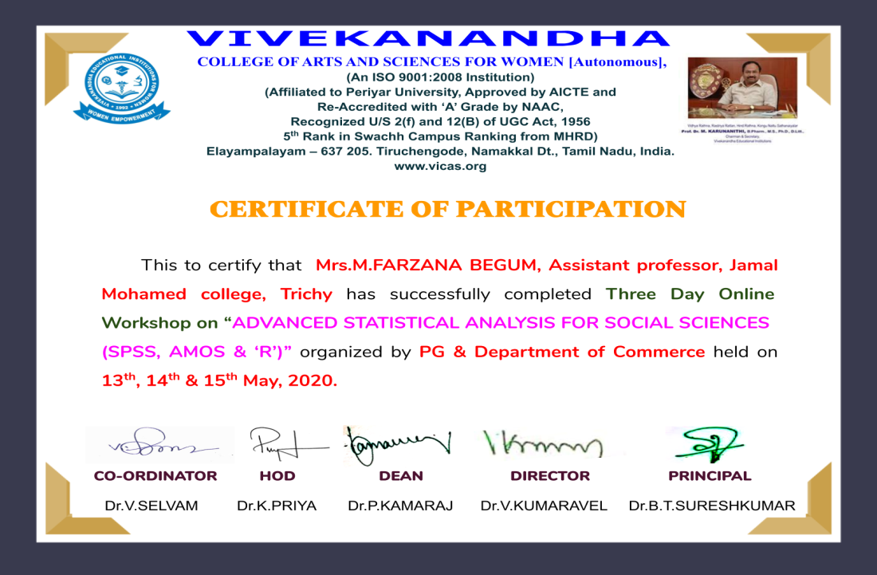
Three days online workshop on “Advanced statistical analysis for social sciences (SPSS,AMOS & “R”) organised by
Vivekanandha College of arts and sciences for women, Nammakkal District.
Participate International conference on Contemporary Trends in Management ,Technology and Engineering and Research paper published on Talent management and its impact for organisational performance of Govt and Private school teachers in Trichirappalli district.
Research paper published on Talent management and its impact for organisational performance of Govt and Private school teachers in Trichirappalli district.
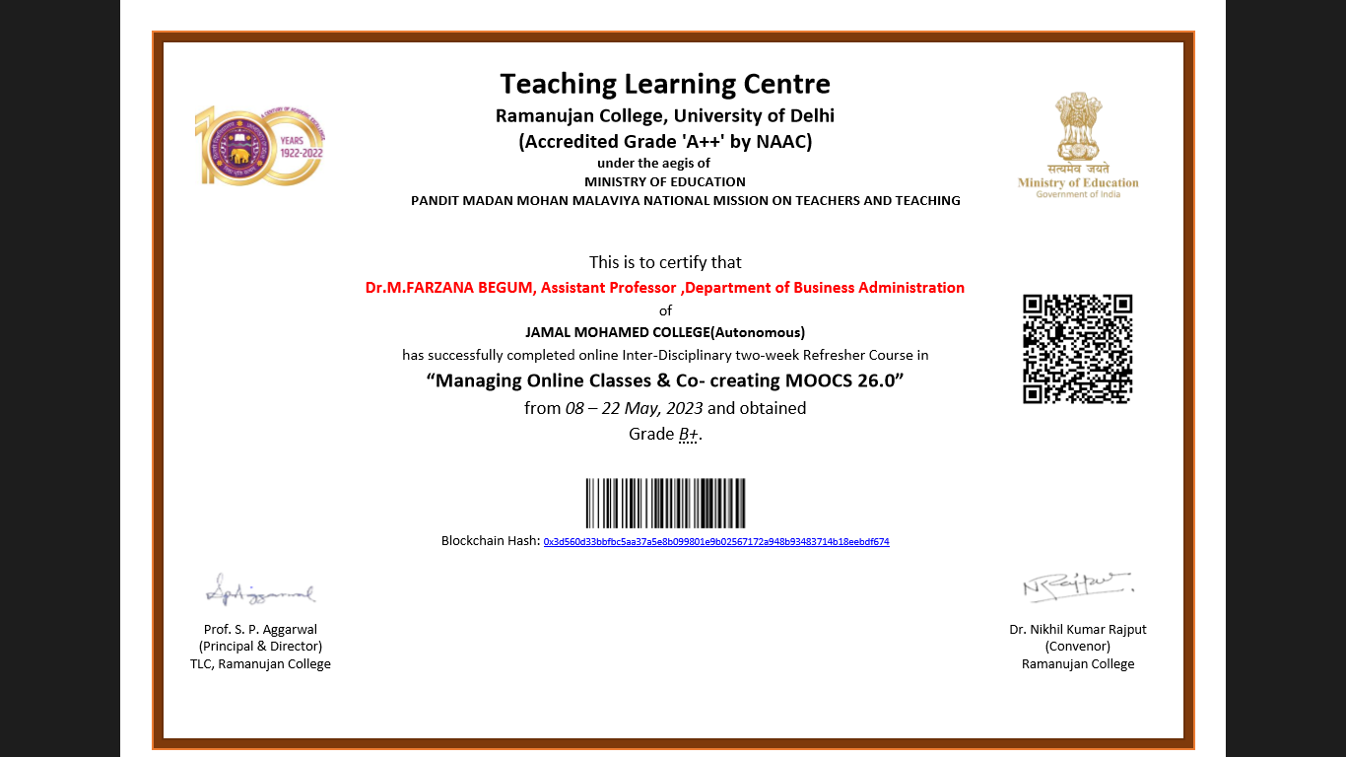  online Inter-Disciplinary two-week Refresher Course in “Managing Online Classes & Co- creating MOOCS 26.0” from  08 – 22 May, 2023. |  | or

PERSONAL PROFILE
Name : M. FARZANA BEGUM
Father’s Name : A.MUSTAFA
D.O.B and Age : 03.02.1982 and 41 years
Gender : Female
Nationality : Indian
Religion : Muslim
Marital Status : Married
Languages known : Tamil, English

DECLARATION
I hereby declare that all the above information is true and best of my knowledge.
Place: Trichy – 20.
Date: 08.07.2023
Yours faithfully

(M.FARZANA BEGUM)

